Discussion Round 3

Revenant
By Meena Alexander

This disease has come back
With frills and furbelows.

You must give your whole life to poetry
Only a few survive if that—

Poems I mean, paper crumpled
Shades of another water—

Far springs are what you long for,
Listening for the slow drip of chemicals

Through a hole in your chest.

If you were torn from me
I could not bear what the earth had to offer.

To be well again, what might that mean?
The flowering plum sprung from late snow,

Ratcheting trill in the blackberry bush
Blood streaks, pluck and throb of mercy.

Discussion Round 4

Former Dutch prime minister and his wife die hand-in-hand in double euthanasia
James Jackson
Sun, February 11, 2024 at 11:20 AM EST

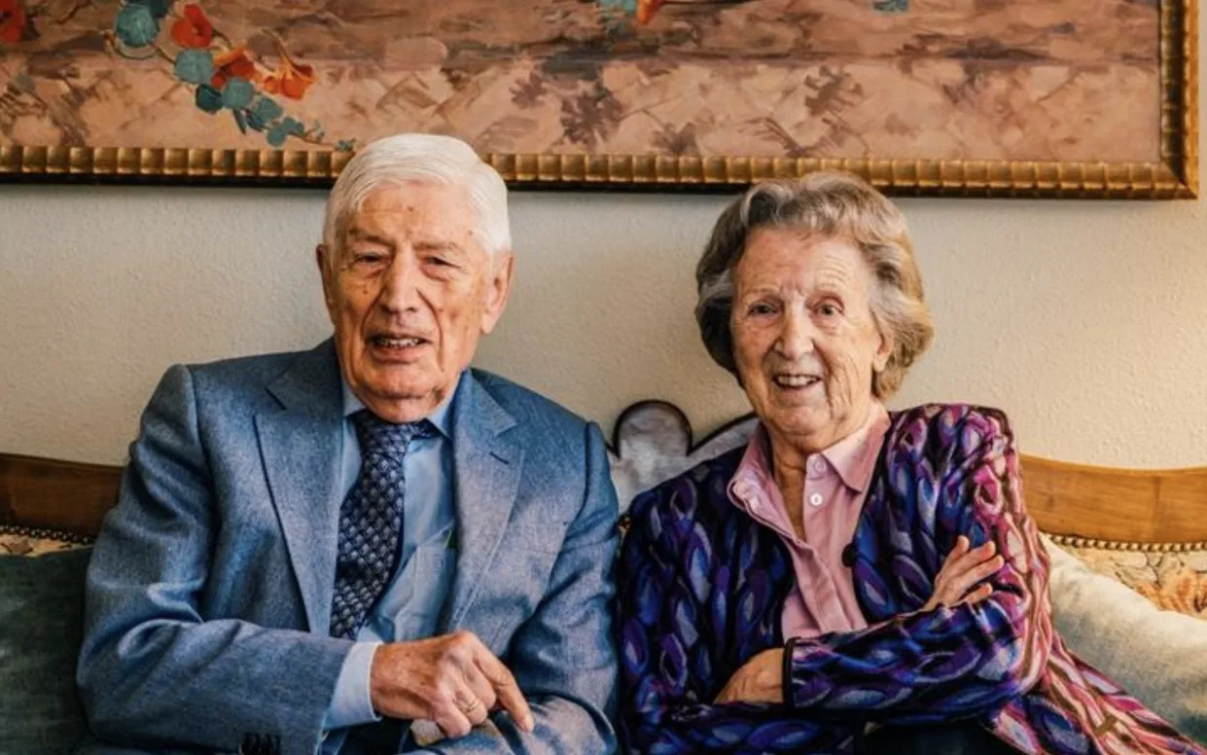
Dries and Eugenie van Agt, both 93, died together as the number of couples in Netherlands choosing joint end to life grows

A former Dutch prime minister and his wife have died hand-in-hand in a rare “double euthanasia”.
Dries van Agt and his wife, Eugenie, were both 93. They were buried together on Thursday. “He died hand in hand with his beloved wife Eugenie van Agt-Krekelberg, the support and anchor with whom he was together for more than 70 years and whom he always continued to refer to as ‘my girl’,” The Rights Forum, a human rights charity he founded, said on Friday. The couple met as students at Nijmegen.
The Rights Forum described him as “idiosyncratic” and said that Van Agt and his wife were very ill, but “couldn’t live without each other”.
A Dutchman of Catholic stock, van Agt served as prime minister between 1977 and 1982. He was popular for his humour and for riding with Tour de France cyclists. He was branded a “Jesuit” and a “mystic” by political rivals.
The former Christian Democrat adopted increasingly left-wing views later in life, opposing his party’s electoral agreement with Gert Wilders’ PVV in 2010.
Van Agt was especially vocal on the Israel-Palestine conflict, writing books on the topic and branding Israeli PM Benjamin Netanyahu “a war criminal” in 2016.
“Double euthanasia” is rare but has been on the rise in the Low Countries, which have some of the most liberal euthanasia laws in the world. There were 26 there in 2020 and 58 in 2022, out of a total of 9000 cases of euthanasia.
Euthanasia and assisted suicide have been legal in the Netherlands since 2002 under specific conditions.
Jozef van der Heijden, a former MP from van Agt’s party, and his wife Gonnie died in a double euthanasia in 2016.
Constance de Vries of the Euthanasia Expertise Center told De Volkskraant, a broadsheet newspaper: “Many people dread the prospect of having to continue on their own, especially when they are 80 and no longer so flexible.”

